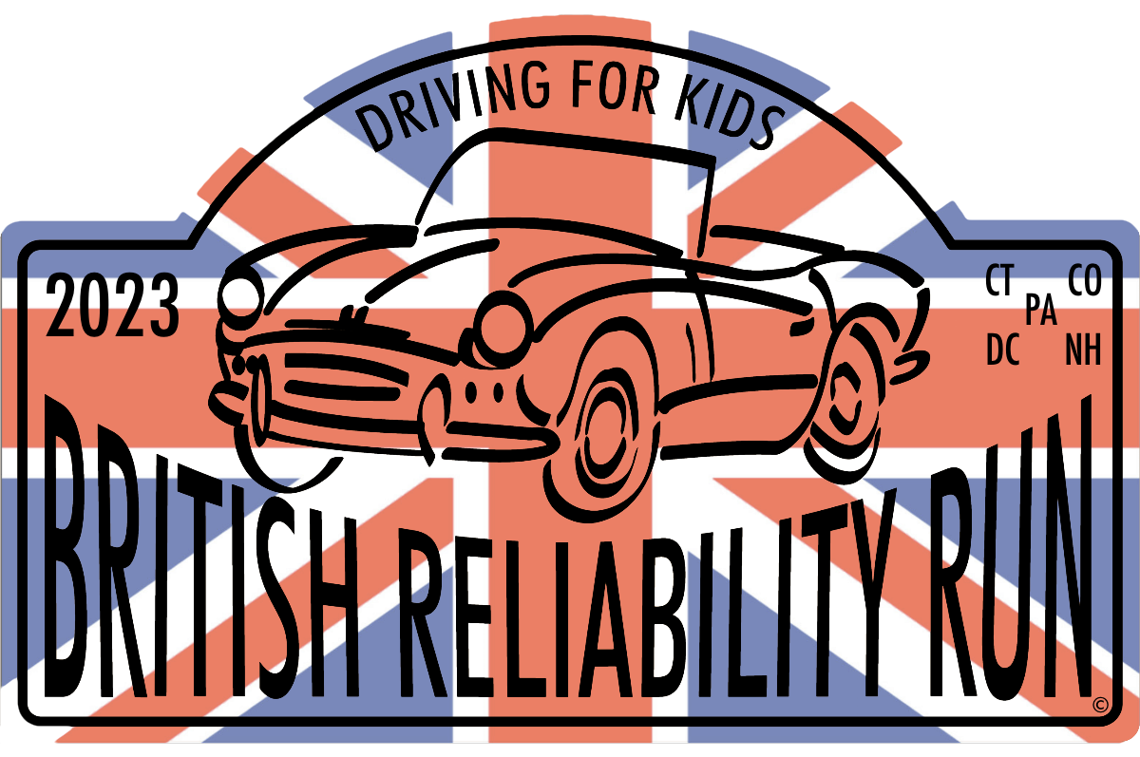

ON OCTOBER 6-8, <team members> ARE DRIVING 500 MILES FOR CHARITY
IN THIS BRITISH CAR:

Delete this box and place 3”x4” picture here

Along with 30 other teams, we are participating in a special event and fundraiser for a very worthwhile cause. The event is called America's British Reliability Run (http://www.britishreliability.org/home-pa/).

We are participating in the PA run where the group is raising money for the Pediatric Rehabilitation program at Shriners Hospital For Children.

We are asking for your help in supporting <YOUR TEAM NAME HERE> in our goal to raise at least $500.00 for Shriners by making a donation.

You can donate directly to my team using the link on our website: http://www.britishreliability.org/2023-teams/ or you can send a check (amount at your discretion) made out to “Shriners Hospitals For Children” directly to me and I will present it to them along with the other ABRR participants. I can handle cash donations as well and all donations will get a 100% tax deduction acknowledgement letter from the charity.

For reference, here are some quick suggested amounts:

1 cent/mi | 2 cents/mi | 5 cents/mi | 10 cents/mi | 25 cents/mi | 50 cents/mi | $1/mi
$5.00 | $10.00 | $25.00 | $50.00 | $125.00 | $250.00 | $500.00

Please send your donation to me at <address>, no later than <date>.
THANKS FOR YOUR SUPPORT!!
<Team Members>

